Flame Sensor Module:
While researching this module I learned that the Flame Sensor Module operates by detecting a flame or light source (with frequency of 760-1100nm) within a detection range of 20cm ~ 100cm at an angle of 60 degrees. When the flame sensor is connected to the Arduino you can choose digital output or analog output. Depending on which one you choose, if the flame sensor detects a flame it will send the information to the arduino which well send it to your computer.

This device could assist robots providing a better way to fight fires. These robots would be able to sense human or animal movement much better than a human could. A robot would be able to sustain extreme amounts of heat without overheating allowing it to pass through fire to assist a human or animal in need of assistance. Firefighters, while they may love their job, are putting themselves at great risks when saving others from fires. Not to mention they are far less reliable in staying alive long enough to save everyone from the building before it falls down. Therefore, these robots would be a much more sensible option when it comes to fighting fires.

While these robots would provide much needed assistance when fighting big fires, they can also prevent ones from happening. For example, if someone had a robot inside their home, and while they leave for the bathroom they leave the stove on and it catches their bacon on fire, the robot would turn on and detect what type of fire and how to put it out before it catches the building on fire.

In conclusion, these devices could provide safety that even humans can't provide. While these devices already provide some safety by being in fire detectors, they could be upgraded to a robot which can react to the alarm. Fire is a dangerous thing and we aren't quite safe enough from it. Take the Gorge as an example, if these robots existed we could've dropped down thousands of them to fight the fire from the inside while we fought the fire from the outside, limiting the amount of area that got burned.

Water Level Sensor:

The water level sensor sends an analog signal depending on how many mm of water it is submerged in. One use this could have is to measure rainfall. Another use could be to show how much water is being used by a shower or something like that. One last use could be to prevent over watering plants.

Ultrasonic Sensor:
OVERVIEW:
Ultrasonic sensors are great for any type of distance measurement, like avoiding obstacles. They are also very inexpensive!

COMPONENTS REQUIRED:
(1) X Elegoo Uno R3
(1) X Ultrasonic Sensor Module
(4) X F-M Wires

How it works:
1. The ultrasonic sensor can detect signals from high level signal.
2.The module automatically sends 40 kHz and detect whether there is a pulse signals back.
3.If it detects a high level signal back it will react as it is programed.

The sensor will send an 8 cycle burst of ultrasound at 40 kHz and raise its echo.It can detect anything from 2 cm-400 cm. The echo will be a distant object that is pulsed with its range of proportion. You can calculate that distance of the object depending on the time it took for the echo to travel back to the module.

CODE:
The code for the ultrasonic sensor is short and simple.By using simple commands we can control the behavior of the sensor.

Servo Motor:
The servo a motor sg90 is a smaller version model. The servo motor sg90 can only rotate 180 degrees.Servo motor has three different colored wires,the orange wire is the signal wire which should be connected to the #9 digital port,the red wire is the power wire which should be connected to the 5v port,the brown wire is the ground which should be connected to the GND port.This servo motor can be used for small jobs.

Laser Emit Sensor:
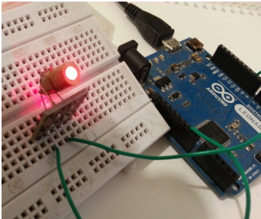
The Arduino Laser Emit sensor can produce a red laser beam. A laser is a
very intense beam of coherent (light with the same frequency and waveform
throughout), monochromatic (light that has the the same wavelength
throughout meaning it is one color) light. The laser sensor has three pins
attached to one side. These pins are placed into the breadboard and then
wires are placed in correct rows to connect the laser sensor to the Arduino.
Once a working program is uploaded to the Arduino, the laser will emit a
red laser beam. Be sure to not look straight into the light as this can be very
harmful to your eyes. Lasers are present in our daily lives. They’re used in DVD players and grocery store scanners.

The Joystick:
The joystick is a complicated mechanism to program but, is simple and tends to be used with two servos. A joystick is close to putting two Potentiometers and a button together. It uses the x and y-axis to determine the movement of the servo. The VRx and VRy are analog and the SW (button) is digital. The button is optional if you do not need to use it, you can use four Dupont wires instead of five. The most common use of a joystick is a controller (see picture below).
https://www.youtube.com/watch?v=kA_pbMR6jVs&vl=en
An analog joystick is a controller that is physically moved and is made of two potentiometers that allows you to control something. One example is a game controller because there is a joystick on it that allows to navigate while playing on games. Another one is used by pilots on airplanes so that they could control the plane. A joystick can be applied in videos games so that you can control the speed of your character, direct your character in a certain way, or even allow them to jump when combined with one of the face buttons. Also, they are used in stick shift cars as they can be moved in different directions.

Game controller: https://www.youtube.com/watch?v=3EMe8rtakjY&authuser=0

Shift Stick: https://www.youtube.com/watch?v=_gmGoQ1dI2E&authuser=0

Avoidance Sensor
The Arduino KY-032 Obstacle avoidance sensor is a module designed to detect obstacles so that a rover outfitted arduino can avoid it.
It uses the infrared reflection principle to detect obstacles. When there is an obstacle in front of it, it blocks and reflects infrared light back to the receiver, telling it that there is an obstacle there. If there is not one, the receiver will not receive any infrared light waves coming back.
Example:
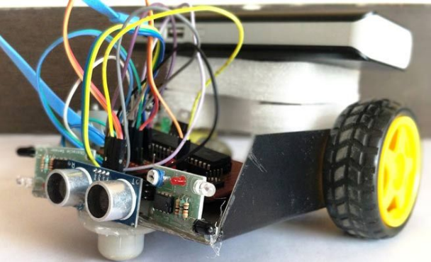
In this example, the infrared obstacle avoidance module helps guide an autonomous rover.
Application: An application for the avoidance sensor could be a tripwire for securing building. If someone passes through the wire, it could set of an alarm.
Tutorial: https://www.sunfounder.com/learn/lesson-23-obstacle-avoidance-sensor-sensor-kit-v1-for-ardui no.html
This tutorial explains how to set up your sensor to the arduino so that when there is an object in front of the sensor, a LED is on. If there is not an obstacle in front of it, the LED will be off.

Digital Temperature Sensor:
Digital Temperature Sensor is a device that provides temperature measurement through an electrical signal. It involves thermistors or RTD (Resistor Temperature Sensors). Thermistors are variable resistors that change their resistance with temperature. Digital temperature sensors are guaranteed accuracy as good as ±0.5°C over a wide temperature range.It also includes all of the errors involved in digitizing the temperature value within the sensor’s accuracy specifications. Digital Temperature Sensor can be used to determine when to turn the heat on or off.

IR Remote:
The Infrared Remote is the same kind of device that controls wireless devices from TV sets to remote-controlled helicopters. Identifiable by a led light on the front of the device, it sends infared light to a receiver. That signal is converted to binary and sent to the Arduino, and can be viewed via the serial monitor. Perhaps I could use it to select which of 5 lights turn on with the number pad. http://www.circuitbasics.com/arduino-ir-remote-receiver-tutorial/

Big Sound Sensor:
This sensor lets you set something to activate when sound has exceeded a set limit. Sound is detected via a microphone and fed into an LM393 op amp. A potentiometer can be used to set the sound level. If the sound level exceeds this limit a light on the module is lit and the signal is set low. There are two different types, one just include a single digital output, the other has an analog output as well as a digital one.using this sensor You can detect whether or not a motor is running ,set a threshold on pump sound so that you know whether or not there is a cavity, In the presence of no sound,you can create an ambiance by turning on music, In the presence of no sound and no motion, and you may go into an energy savings mode and turn off the lights. When less sensitive it takes more sound to trigger the device, when it is more sensitive it takes less sound to trigger the device.

